**Projeto BRA/12/G31**

Planejamento Nacional da Biodiversidade para Apoio à Implementação do Plano Estratégico da CDB 2011-2020 no Brasil

**Consultora: Agnes L. Velloso**

**Produto 3 – Parte II do 5º RN para a CDB**

**09 julho 2014**

**BRAZIL**

**Fifth National Report to the CBD**

**DRAFT** – **NOT** TO BE DISCLOSED

09 July 2014

**Part II - The national biodiversity strategy and action plan (NBSAP), its implementation, and the mainstreaming of biodiversity**

**2.1. Status and updating of the Brazilian NBSAP**

### Brazilian NBSAP background and status

Responding to the CBD Strategic Plan for 2010 and its targets, Brazil adopted a National Biodiversity Strategy comprised of several previously existing environmental policies, later complemented by additional policies and programs (see Brazil’s 4th National Report to the CBD). The first effort to define Brazilian National Biodiversity Targets resulted in a set of 51 targets, some of which more restrictive than the global targets for 2010. As documented in the 4th National Report to the CBD, only two of the 51 targets were achieved, notable progress was obtained for 14 others, but significant challenges remained, as only modest or no advances were obtained towards the achievement of all remaining targets. This is explained by weaknesses in the criteria and process to define the set of national targets, the lack of indicators and monitoring systems to adequately measure target achievement, as well as challenges related to the national implementation of the CBD.

Following the definition of 20 new Global Biodiversity Targets at COP-10 (Nagoya, 2010) and in an attempt to avoid the mistakes that prevented the achievement of most national and global targets, the need arose to design a different strategy to review and update the NBSAP and 2010 targets, this time effectively involving stakeholders of all sectors. This new approach could be considered as the first step in the construction of a new National Strategy for 2011-2020.

Implementation of the new approach began with a broad consultation effort to achieve a collective construction of the revised NBSAP and new National Biodiversity Targets for 2020 in an initiative known as Dialogues on Biodiversity, which resulted in the definition of a more concise set of 20 National Targets (see section 2.1.2). Also as part of the new approach various other initiatives are being carried out in parallel, one of which is the development of a Governmental Action Plan for the Conservation and Sustainable Use of Biodiversity (see section 2.1.3), complemented by the construction of the PainelBio (see section 2.1.4) to assist in the implementation and monitoring of the National Targets. Initial steps are being carried out to design a national strategy for the mobilization of resources and capacity (see section 2.1.5).

* + 1. **Dialogues on Biodiversity and National Biodiversity Targets 2020**

In 2013 the National Biodiversity Commission – CONABIO, complying with its legal duties and the international commitment with the CBD, established the national biodiversity targets for the period of 2011-2020, as spelled out in the annex of its Resolution 06/2013 and further down in this section, and proposed their implementation by the Federal Government.

To define these new targets, the Ministry of the Environment, in partnership with various environmental institutions, launched in 2011 the initiative on “**Dialogues on Biodiversity: building the Brazilian strategy for 2020**”. The initiative had as its main objective to establish, through an intense participatory process, the national biodiversity targets related to the Biodiversity Strategic Plan 2011-2020 of the Convention on Biological Diversity. On the course of 2011, five broad face-to-face consultation events were held, in addition to numerous preparation and qualification meetings with five sectors: the business sector, civil environmental society, academia, government (federal and state), and indigenous peoples and traditional communities. At those meetings, participating sectors prepared proposals for the national biodiversity targets according to sector-specific stands and needs, taking into consideration the 20 Global Biodiversity Targets, known as the “Aichi Targets”.

To coordinate the complex consultation process, a broad governing structure was established involving representatives of all sectors in two levels: five sectoral committees and a smaller strategic committee. The five sectoral committees supported the technical organization of the consultation events by defining lists of participants, identifying speakers, the methodology and dynamics of the meetings, products expected from the meetings, among other technical details. On the other hand, the strategic committee was composed by a smaller group of representatives of each sector and was responsible for the strategic decisions of the initiative. In addition to the four organizing institutions (MMA, IUCN, WWF-Brasil, and IPÊ), a total of 19 institutions of the five sectors were involved in the Dialogues and over 400 participants attended the consultation meetings. It could be said that, in addition to the results achieved and documents produced, this strong participatory governance structure was one of the most notable aspects of the process.[1]

Twenty-five documents were generated from the work of the sectoral meetings (5 for each of the 5 meetings), containing proposals for the national biodiversity targets for the 2011-2020 period, as well as 517 intermediate sub-targets to be achieved on the course of the 2013-2017 period. All proposals were consolidated in a single document, which was named “Base document for public consultation”. This document was posted online for public consultation by the Ministry of the Environment from 19 December 2011 to 31 January 2012. The public consultation process had the objective to obtain additional contributions from the Brazilian society for the preparation of the national biodiversity targets 2011-2020, as well as a critical analysis of the targets proposed by the consulted sectors.

A final meeting was held with representatives of all five sectors to discuss the final document containing 20 proposed national targets, as well as general recommendations to improve the national CBD implementation process. The final meeting also indicated the need to carry out continuous periodic assessment of the achievement status regarding the national targets.[2]

Taking these contributions as a starting point, CONABIO discussed the national targets during five ordinary meetings: the 47th Meeting on 26 April 2012; the 48th Meeting on 27 June 2012; the 49th Meeting on 20 August 2012; the 51st Meeting on 25 April 2013; and the 52nd Meeting on 26 and 27 June 2013; as well as during the 15th extraordinary meeting on 01 June 2012.

At the end of the 52nd Meeting, CONABIO approved the final version of the text of the national targets and the proposal for the preparation of supporting text containing CONABIO considerations on the background of the preparation process and on the implementation of the approved targets, to be presented in the form of directives for the internalization and implementation of the national biodiversity targets 2011-2020 as presented in Table 32 below.

**Table 32:** National Biodiversity Targets 2011-2020

|  |
| --- |
| **Strategic Objective A – Address the underlying causes of biodiversity loss by mainstreaming biodiversity considerations across government and society** |
| **National Target 1:** By 2020, at the latest, Brazilian people are aware of the values of biodiversity and the steps they can take to conserve and use it sustainably. |
| **National Target 2:** By 2020, at the latest, biodiversity values, geo-diversity values, and socio-diversity values have been integrated into national and local development and poverty reduction and inequality reduction strategies, and are being incorporated into national accounting, as appropriate, and into planning procedures and reporting systems. |
| **National Target 3:** By 2020, at the latest, incentives harmful to biodiversity, including the so-called perverse subsidies, are eliminated, phased out or reformed in order to minimize negative impacts. Positive incentives for the conservation and sustainable use of biodiversity are developed and applied, consistent and in harmony with the CBD, taking into account national and regional socio economic conditions. |
| **National Target 4:** By 2020, at the latest, governments, private sector and stakeholders at all levels have taken steps to achieve or have implemented plans for sustainable production and consumption to mitigate or prevent negative impacts from the use of natural resources. |
| **Strategic Objective B – Reduce the direct pressures on biodiversity and promote sustainable use** |
| **National Target 5:** By 2020, the rate of loss of native habitats is reduced by at least 50% (in comparison with the 2009 rate) and, as much as possible, brought close to zero, and degradation and fragmentation is significantly reduced in all biomes. |
| **National Target 6:** By 2020 all stocks of any aquatic organism are managed and harvested sustainably, legally and applying ecosystem based approaches, so that overharvesting is avoided, recovery plans and measures are in place for depleted species, fisheries have no significant adverse impacts on threatened species and vulnerable ecosystems, and the impacts of fisheries on stocks, species and ecosystems are within safe ecological limits, when scientifically established. |
| **National Target 7:** By 2020 the incorporation of sustainable management practices is disseminated and promoted in agriculture, livestock production, aquaculture, silviculture, extractive activities, and forest and fauna management, ensuring conservation of biodiversity. |
| **National Target 8:** By 2020, pollution, including from excess nutrients, has been brought to levels that are not detrimental to ecosystem function and biodiversity. |
| **National Target 9:** By 2020, the National Strategy on Invasive Alien Species is fully implemented, with the participation and commitment of states and the elaboration of a National Policy, ensuring the continuous and updated diagnosis of species and the effectiveness of Action Plans for Prevention, Contention and Control. |
| **National Target 10:** By 2015, the multiple anthropogenic pressures on coral reefs, and other marine and coastal ecosystems impacted by climate change or ocean acidification are minimized, so as to maintain their integrity and functioning. |
| **Strategic Objective C: To improve the status of biodiversity by safeguarding ecosystems, species and genetic diversity** |
| **National Target 11:** By 2020, at least 30% of the Amazon, 17% of each of the other terrestrial biomes, and 10% of the marine and coastal areas, especially areas of particular importance for biodiversity and ecosystem services, are conserved through protected areas foreseen under the SNUC Law and other categories of officially protected areas such as Permanent Protection Areas, legal reserves, and indigenous lands with native vegetation, ensuring and respecting the demarcation, regularization, and effective and equitable management, so as to ensure ecological interconnection, integration and representation in broader landscapes and seascapes. |
| **National Target 12:** By 2020, the risk of extinction of threatened species has been significantly reduced, tending to zero, and their conservation status, particularly of those most in decline, has been improved. |
| **National Target 13:** By 2020, the genetic diversity of microorganisms, cultivated plants, farmed and domesticated animals and of wild relatives, including socio-economically as well as culturally valuable species, is maintained, and strategies have been developed and implemented for minimizing the loss of genetic diversity. |
| **Strategic Objective D: Enhance the benefits to all from biodiversity and ecosystem services** |
| **National Target 14:** By 2020, ecosystems that provide essential services, including services related to water, and contribute to health, livelihoods and well-being, are restored and safeguarded, taking into account the needs of women, traditional peoples and communities, indigenous peoples and local communities, and the poor and vulnerable. |
| **National Target 15:** By 2020, ecosystem resilience and the contribution of biodiversity to carbon stocks has been enhanced through conservation and restoration actions, including restoration of at least 15% of degraded ecosystems, prioritizing the most degraded biomes, hydrographic regions and ecoregions, thereby contributing to climate change mitigation and adaptation and to combatting desertification. |
| **National Target 16:** By 2015, the Nagoya Protocol on Access to Genetic Resources and the Fair and Equitable Sharing of Benefits Arising from their Utilization is in force and operational, consistent with national legislation. |
| **Strategic Objective E: Enhance the implementation through participatory planning, knowledge management and capacity building** |
| **National Target 17:** By 2014, the national biodiversity strategy is updated and adopted as policy instrument, with effective, participatory and updated action plans, which foresee periodic monitoring and evaluation. |
| **National Target 18:** By 2020, the traditional knowledge, innovations and practices of indigenous peoples, family rural producers and traditional communities relevant for the conservation and sustainable use of biodiversity, and their customary use of biological resources, are respected, in accordance with their uses, customs and traditions, national legislation and relevant international commitments, and fully integrated and reflected in the implementation of the CBD, with the full and effective participation of indigenous peoples, family rural producers and traditional communities, at all relevant levels. |
| **National Target 19:** By 2020, the science base and technologies necessary for enhancing knowledge on biodiversity, its values, functioning and trends, and the consequences of its loss, are improved and shared, and the sustainable use of biodiversity, as well as the generation of biodiversity-based technology and innovation are supported, duly transferred and applied. By 2017, the complete compilation of existing records on aquatic and terrestrial fauna, flora and microbiota is finalized and made available through permanent and open access databases, with specificities safeguarded, with a view to identify knowledge gaps related to biomes and taxonomic groups. |
| **National Target 20:** Immediately following the approval of the Brazilian targets, resources needs assessments are carried out for the implementation of national targets, followed by the mobilization and allocation of financial resources to enable, from 2015 on, the implementation and monitoring of the Strategic Plan for Biodiversity 2011-2020, as well as the achievement of its targets. |

**Source:** CONABIO Resolution 06/2013, of 03 September 2013.

CONABIO also established the directives for the internalization and implementation of the national biodiversity targets 2011-2020, as follows:

|  |  |
| --- | --- |
| i. | Promote under CONABIO, whenever necessary, the definition of the concepts employed in the text of the targets, with the purpose of establishing the clear and objective understanding of the intended meaning, including through the constitution of working groups, expert consultations, and technical workshops; |
| ii. | Propose the establishment, under CONABIO, of analysis criteria and indicators for evaluating the implementation process of the national targets, in a participatory manner with different sectors of society; |
| iii. | Propose the implementation of the national biodiversity targets 2011-2020 in a coordinated manner with a national strategy and an action plan for the conservation and sustainable use of biodiversity, recognizing the efforts and policies related to the national targets; |
| iv.a. | Promote the adoption of incentives aimed at the implementation of the national targets; |
| iv.b. | Promote the establishment of legislation and regulations aimed at the implementation of the national targets; |
| v. | Consider a broad agenda, comprising inter-institutional and multidisciplinary actions to be developed by different agencies of the federal, state and municipal governments, in addition to various sectors of society; |
| vi. | Consider the specific characteristics of each biome and macro geopolitical region of the country, in order to balance the actual risks to remaining ecosystems, technological viability, and economic, social and environmental aspects, taking into account the Ecological-Economic Zonings; |
| vii. | Promote the permanent generation, updating, and incorporation of technical-scientific knowledge in the process of implementing the national targets. |

During the Rio+20, an event was held to present the results of the Dialogues on Biodiversity, as well as the proposal of creation of the Brazilian Panel on Biodiversity – PainelBio, as one of the potential tools for the implementation, monitoring, generation of knowledge, and capacity development for achieving the national targets.

* + 1. **Governmental Action Plan for the Conservation and Sustainable Use of Biodiversity**

In parallel to the process to define the National Biodiversity Targets for 2020, the Ministry of the Environment – MMA in partnership with the Ministry of Planning – MPOG and the Brazilian Fund for Biodiversity – FUNBIO, started a dialogue with other sectors to develop a Governmental Action Plan for the Conservation and Sustainable Use of Biodiversity with the objective to minimize or halt the loss of national biodiversity. This Action Plan also seeks to enhance the synergy among the ministries and other federal agencies, in addition to optimize the use of resources, the achievement of targets established in the Federal Multi-year Plan (PPA – *Plano Plurianual*) 2012-2015, the maintenance of social benefits, and the improvement in social understanding on ecosystem services provided by biodiversity. The Plan should contribute to the internalization and achievement of the Global Aichi Targets.

In the first step to build the Governmental Action Plan, an analysis to identify the causes and consequences related to the loss of biodiversity was carried out to obtain the federal government’s view of the problem. The analysis was based on the results of 40 interviews carried out with representatives of 17 Ministries and four federal agencies, with questions on the causes, consequences, expectations and vulnerabilities of the loss of biodiversity. The resulting information was used to build a “problem tree” with three themes, in six workshops with the participation of MMA, MPOG and FUNBIO, which was then adjusted and validated in three inter-ministerial workshops with the participation of 13 Ministries and 18 subordinate agencies. A final series of three workshops was carried out in November and December 2013 with the participation of 24 Ministries to validate the final version of the problem tree. The problem tree organized the possible causes for biodiversity loss identified by all the participating federal agencies along three main themes: (i) Theme 1 – Conservation: sustainable production and consumption; (ii) Theme 2 – Habitat: ecosystem conservation; and (iii) Theme 3 – Valuation: promotion of the value of biodiversity and associated traditional knowledge (Figures 42-A, 42-B, and 42-C).

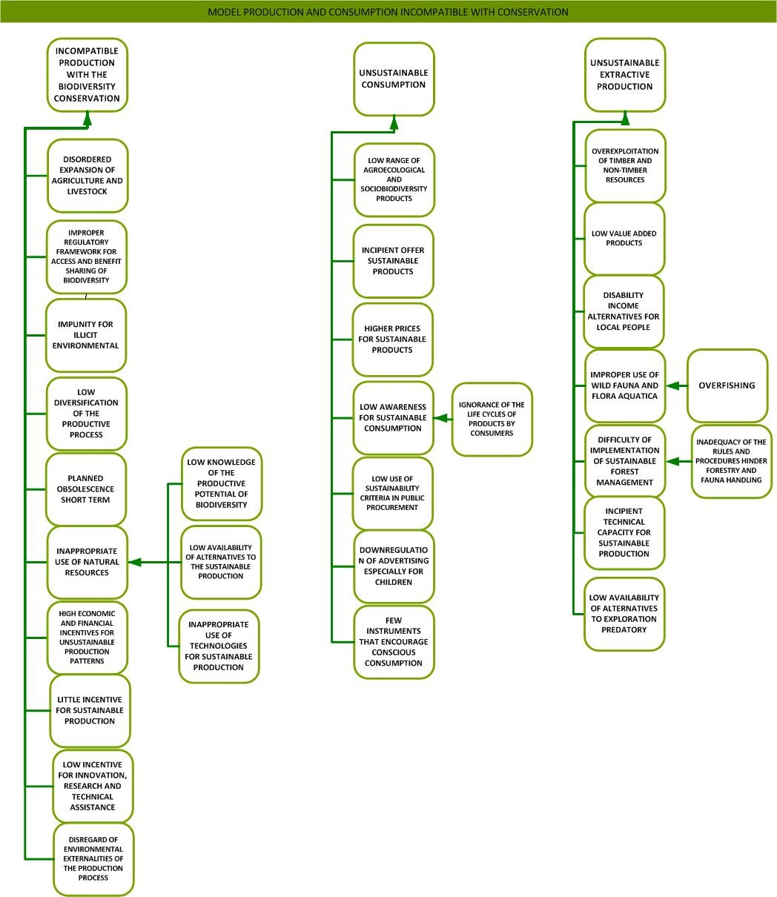

**Figure 42-A:** Problem tree for the causes of biodiversity loss, Theme 1 – Conservation: sustainable production and consumption.

**Source:** Draft Governmental Action Plan, 2014 unpublished.

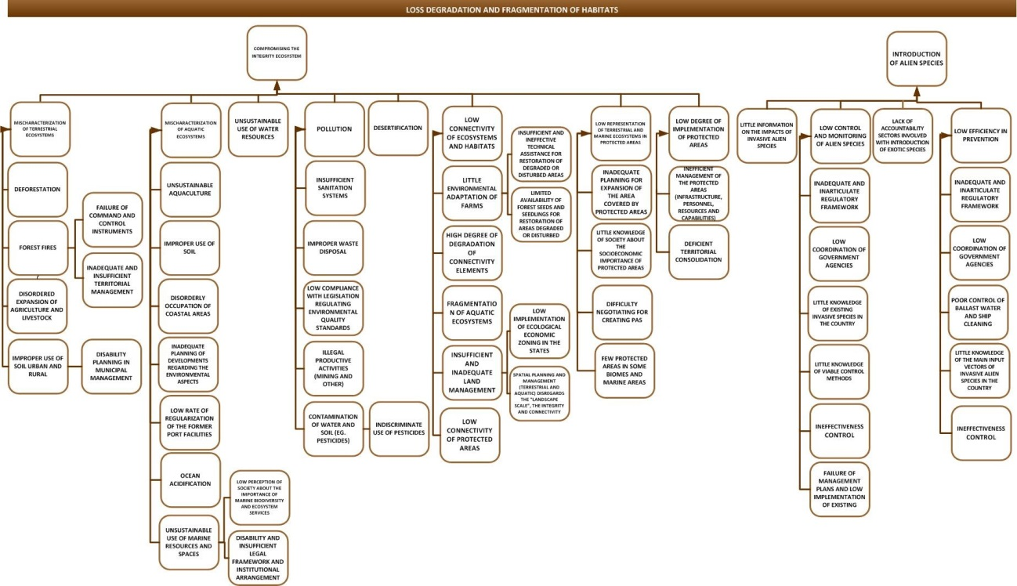

**Figure 42-B:** Problem tree for the causes of biodiversity loss, Theme 2 – Habitat: ecosystem conservation.

**Source:** Draft Governmental Action Plan, 2014 unpublished

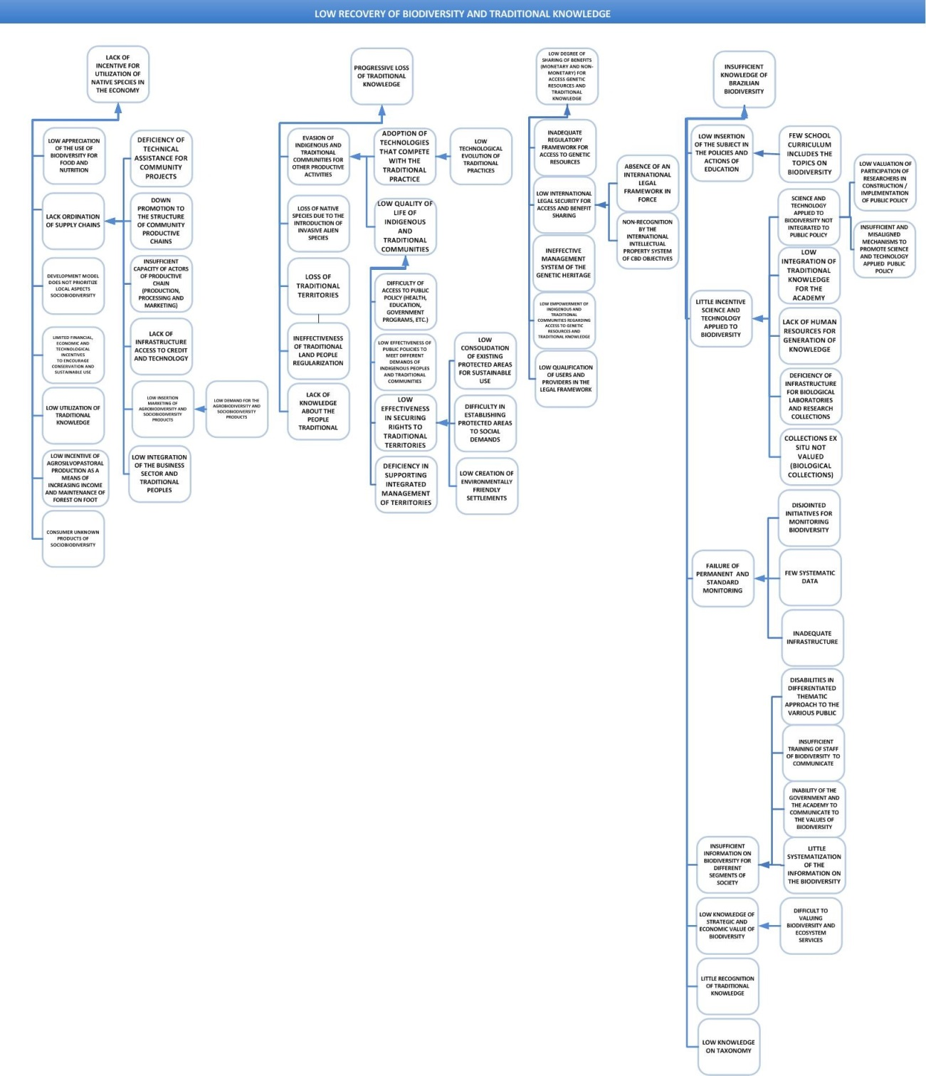

**Figure 42-C:** Problem tree for the causes of biodiversity loss, Theme 3 – Valuation: promotion of the value of biodiversity and associated traditional knowledge.

**Source:** Draft Governmental Action Plan, 2014 unpublished

The three strategic themes or primary causes (conservation, habitat, and valuation) were broken down into 158 causes at six different levels. The problem tree lists 33 causes under Theme 1 – Conservation; 60 causes under Theme 2 – Habitat; and 65 causes under Theme 3 – Valuation. This schematic view of the causes of biodiversity loss represents a crucial starting point for the inter-ministerial dialogue necessary for agreeing and validating the Action Plan in preparation.

Once the set of causes for biodiversity loss were identified in a broad participatory manner, the ministries and subordinate agencies were invited to join efforts and resources to revert this situation. With this objective, the second round of inter-ministerial workshops also identified the existing and planned initiatives under each agency that can contribute to combat the causes identified in the validated problem tree. The participating agencies detailed their activities that contribute to combat biodiversity loss as follows: degree of impact; current implementation status of the activity/initiative; national or regional scope; biome; target public/beneficiaries; expected products; targets (2013-2015 and up to 2020); other funding sources; total budget; and responsible agency listed in the PPA.

As this process was occurring in parallel to the definition and approval of the new set of National Biodiversity Targets, once the National Biodiversity Commission – CONABIO approved the new Targets in 2013, a methodology was defined to select priority causes of biodiversity loss among those identified in the problem tree.

In 2014, meetings were carried out to define the structure of the Governmental Action Plan, and an analysis of information consistency and gaps was initiated. Additionally, as a large number of existing initiatives to combat biodiversity loss were identified, it was decided to prioritize some of them for monitoring actions. A final version of the Governmental Action Plan is expected to be available in late 2014.

* + 1. **PainelBio**

At the end of the Dialogues on Biodiversity process in 2012, to complement the Governmental Action Plan and insure the necessary involvement of all sectors in order to achieve biodiversity conservation targets, a discussion was initiated among the sectors that participated in the Dialogues process to develop a multi-stakeholder panel to promote the achievement of the National Biodiversity Targets. This initiative was launched during the Rio+20 meeting (2012) and its proposed format has been discussed and detailed along 2012 and 2013. The most recent meeting took place on 27 May 2014, when a Constitution Agreement was agreed upon by participating institutions[3], which should be signed within the next months by the different sectors’ stakeholders that will compose the proposed Biodiversity Panel (PainelBio). Some signatures were already obtained and the first meeting of the Panel’s Board of Directors is scheduled for 22 July 2014.

The Panel’s mission was defined as to “contribute for the conservation and sustainable use of Brazilian biodiversity by promoting synergy between institutions and knowledge, making scientific information available to society, promoting capacity building at various levels, and supporting decision making processes and public policies for the achievement of the Aichi Targets in Brazil”. The IUCN-Brasil is the Executive Secretariat of the Biodiversity Panel.

Another important result arising from this meeting was the definition of a participatory process for building indicators to evaluate the implementation of the National Biodiversity Targets. This proposal involves capacity building with the assistance of the Biodiversity Indicators Partnership (<http://www.bipindicators.net/>), after which five workshops will be held, each addressing one of the five strategic objectives of the National Biodiversity Targets. These workshops should have the participation of various sectors and institutions important for the implementation of strategies for the integration of the National Targets in the multiple sectors, and involve the discussion and definition of concepts related to the National Targets, as well as the development of indicators to measure the degree of achievement of these Targets and a monitoring strategy. The proposed timeline indicates that these workshops should take place between July 2014 and April 2015.

* + 1. **Strategy for resource mobilization and capacity**

As a crucial element for enabling the continuous efforts towards implementing the NBSAP and achieving the National and Aichi Biodiversity Targets, a national strategy for the mobilization of resources and for meeting capacity needs is being designed. The Ministry of the Environment is in the process of hiring consultants to assist in the preparation of this strategy and provide an assessment of existing capacity at the state and federal levels to support strategy development. Results from these contracts should be available by mid-2015 and will be incorporated into the updated NBSAP.

The Ministry of the Environment is also currently negotiating with the Institute of Applied Economic Research – IPEA the national mapping of resources invested in biodiversity. IPEA is already working on the quantification, analysis and monitoring of environmental expenditures within the federal government, with the objective of preparing a proposal for enhancing effectiveness of governmental environmental expenditures. This analysis should contribute to a better understanding of the management and operation of the national environmental policies and can support further public policies analyses to suggest implementation adjustments and/or plan future actions. Negotiations between MMA and IPEA seek to broaden the scope of the analysis to include specifically the biodiversity theme, and both the state and federal levels.

IPEA’s methodology considers three criteria: (i) expenditures must be recorded in the official budget or within the implementing institutions (extra-budget expenditures); (ii) information collected should be comparable at the international level with other methodologies for assessing environmental expenditures; and (iii) data should compose continuous and comparable annual historical series. The planned phases of this analytical study are: (1) strategic planning for the study; (2) development of the methodology for defining the parameters for environmental expenditures; (3) classification of the budget lines for environmental expenditures; (4) establishment of cooperation agreements with institutions responsible for providing relevant data (MMA and Federal Budget Secretariat – SOF); (5) structuring of a database containing the classification of environmental expenditures, starting with PPA 2008-2011; and (6) data analysis and publication of the collected information.

In the future, IPEA intends to transform this study into a permanent research line, yearly updating the data on environmental expenditures, and expand to include both the state and municipal levels. In 2014, IPEA is defining the method to classify environmental structures and structuring the database with federal budget expenditures.

In parallel, discussions are being carried out among MMA, the Brazilian Business Council for Sustainable Development – CEBDS, the National Confederation of Industries – CNI, and IPEA to define a common methodology for inventorying environmental expenditures within the private sector. To this purpose, the classification of environmental expenditures under IPEA’s methodology will be applied, which will involve the analysis of items directly and indirectly related to biodiversity.

Additionally, Brazil hosted two international events in April 2014 on resource mobilization: a capacity building workshop and a meeting of the High-Level Panel on Global Assessment of Resources for Implementing the Strategic Plan for Biodiversity 2011-2020 (see section 2.2.3).

* + 1. **Next steps in NBSAP updating**

Several activities directly related to the NBSAP updating process have been initiated or planned following the definition of the National Biodiversity Targets for 2020, some of which are ongoing and some have not yet started. The current plan and estimated timeline for NBSAP updating is shown below (Table 33).

**Table 33:** Planned actions and estimated timeline for NBSAP updating.

|  |  |  |
| --- | --- | --- |
| **Concluded actions** | **Start** | **Conclusion** |
| Establishment of the National Biodiversity Targets 2011-2020 | 2011 | Sep/2013 |
| **On-going actions** | **Start** | **Conclusion** |
| Governmental Action Plan for the Conservation and Sustainable Use of Biodiversity | 2012 | 2014 |
| Preparation of the 5th National Report to the CBD | Feb/2014 | Aug/2014 |
| Establishment and operationalization of the Biodiversity Panel – PainelBio | 2012 | Jul/2014 |
| **Actions to be initiated** | **Start** | **Conclusion** |
| Definition of indicators and monitoring strategy for the National Biodiversity Targets | Jul/2014 | Apr/2015 |
| Technical workshops and validation of the Governmental Action Plan for the Conservation and Sustainable Use of Biodiversity, with the participation of various sectors | Aug/2014 | Dec/2014 |
| Development of the strategy for capacity and resources mobilization | Jun/2014 | Jun/2015 |
| Final document of the updated NBSAP | Aug/2014 | Jul/2015 |

**Source:** Ministry of the Environment/SBF/DCBio, June 2014

* + 1. **Sub-national biodiversity strategies**

To-date, only the state of São Paulo has concluded the development and started implementation of a sub-national biodiversity strategy and action plan. At least two other states have initiated the development of sub-national strategies (Ceará and Espírito Santo), and at least three others have developed or are preparing a state policy on biodiversity (Minas Gerais, Bahia, and Tocantins).

The São Paulo Action Plan[4] (*Plano de Ação de São Paulo*) 2011-2020 was launched in 2013 and translates the Aichi Targets to the state level, proposing the development and implementation of projects, as well as specific products to contribute to the conservation and sustainable use of biodiversity. The Action Plan combines on-going actions under the São Paulo Environmental System and new strategies identified through the Action Plan preparation process. Seeking the financial viability for the implementation of its Action Plan, São Paulo state integrated Target 20 (financial resources) into all planed state actions. The São Paulo Action Plan was prepared before the definition of the National Biodiversity Targets and contains seven main actions, each related to a specific project (ongoing or planned), as shown in the state’s vision of the Aichi Targets (Figure 43).



**Figure 43:** São Paulo state’s vision of the Aichi Targets.

**Source:** <http://portaldabiodiversidade.sp.gov.br/files/2014/02/Aichi_impressao_06_02_15_pdf_final.pdf>

In 2011, São Paulo state created the São Paulo Commission on Biodiversity (*Comissão Paulista da Biodiversidade*) with the objective to coordinate the development and implementation of the Aichi Targets within the entire state territory. The Commission acts through integrated actions involving various state agencies, business sector, academia and civil society, guided by the São Paulo Action Plan.[5]

* 1. **Integration of biodiversity in sectoral strategies, plans and programs**

* + 1. **Biodiversity and sectoral programs and initiatives**

The federal Multi-year Plan (PPA – *Plano Plurianual*) prepared every four years by the federal government with input from all sectors contains all ongoing or planned sectoral programs and activities for a given four-year period. During the process to build the Governmental Action Plan for the Conservation and Sustainable Use of Biodiversity in 2012 (see section 2.1.3), a preliminary analysis was carried out on the current PPA (2012-2015) to identify the listed national public policies that contribute to reverse the causes of biodiversity loss listed in the problem tree and to the achievement of the Aichi Biodiversity Targets.

This analysis identified, with the assistance of 31 ministries and subordinate federal agencies, a total of 1,303 PPA activities thus distributed among the three main themes: (i) 412 sectoral activities impacting Theme 1 – Conservation: sustainable production and consumption; (ii) 430 sectoral activities impacting Theme 2 – Habitat: ecosystem conservation; and (iii) 461 sectoral activities impacting Theme 3 – Valuation: promotion of the value of biodiversity and associated traditional knowledge.

A few examples of existing initiatives and actions that contribute significantly to integrate biodiversity conservation into other sectors, as well as to develop cross-sectoral joint initiatives would be the Ecological and Economic Zoning – ZEE (landscape planning instrument, see section 1.4.5); the Economics of Ecosystems and Biodiversity – TEEB initiative (cross-sectoral biodiversity valuation initiative, see section 1.2.1.2); the PPCDAm, PPCerrado and PAS (public policies to combat deforestation, see section 1.3.3); among many others.

* + 1. **Synergy among UN Conventions[6]**

At the political level and particularly at the technical level, Brazil is implementing the three UN environmental conventions (Climate Change – UNFCCC, Biodiversity – CBD and Desertification – UNCCD) in a manner that seeks to establish and strengthen communication, coordination and synergy among them.

The Ministry of the Environment (MMA) is the national focal point for the CBD through its Secretariat of Biodiversity and Forests (SBF), and for the UNCCD through its Secretariat of Extractive Activities and Sustainable Rural Development (SEDR). The physical proximity and, to a great extent, the similarity of actions necessary to achieve these conventions’ objectives greatly facilitate technical cooperation on a daily basis, even though this interaction is not formalized. Teams responsible for coordinating the implementation of these two conventions frequently work together to plan and implement joint actions that promote the restoration and sustainable use of biodiversity and forest or natural resources, particularly in the semi-arid Caatinga biome, where most of UNCCD actions are focused.

For example, the two teams jointly prepared the terms of reference for a call for proposals launched in 2011, targeting the sustainable use of forest resources in three Caatinga regions that heavily deplete timber resources in the form of firewood for plaster production (Chapada do Araripe, in Pernambuco), or ceramics/brick production (Baixo Jaguaribe, in Ceará, and Xingó, in Alagoas). The objective of this call for proposals is to promote the sustainable forest management, energy efficiency and sustainability in industries, and energy-efficient domestic cooking stoves. The latter objective also positively impacts on health and gender issues, in addition to environmental conservation. The selected projects, currently ongoing, are funded by the federal bank CAIXA through its Socio-environmental Fund and are monitored and receive technical support from MMA through the National Fund for the Environment – FNMA and the technical teams responsible for CBD and UNCCD implementation. These regional projects may also generate input for the development and implementation of public policies, as CAIXA is one of the major federal financial agencies that finance housing and public infrastructure construction and is striving to adopt more sustainable practices in its investments.

The national CBD and UNCCD teams also prepare other similar terms of reference to promote conservation projects (creation of protected areas and conservation activities in protected areas), as well as projects on the sustainable management of biodiversity and natural resources through other fund, such as the Climate Fund (*Fundo Clima*), Tropical Forest Conservation Act – TFCA, and National Fund for Forestry Development (*Fundo Nacional para o Desenvolvimento Florestal*). The ultimate objective of promoting such projects is to stimulate activities and sectors that maintain the Caatinga ecosystems, as well as to combat the causes of deforestation in the Caatinga, which are mainly represented by firewood as a household and industry energy source, and non-sustainable livestock activities (overgrazing and planted pastures with alien species). Additionally, SBF is a member of the National Commission on Combat to Desertification, a national body connected to UNCCD which defines the implementation of the National Plan under this convention, as well as the National Policy on Combat to Desertification, currently being discussed by Congress. The UNCCD team was also invited to participate in the SBF exercise to revise the Priority Areas for the Conservation and Sustainable Use of the Caatinga.

Synergy between CBD and UNFCCC leans more towards the political than the technical side. The national focal point for the UNFCCC is the Ministry of Science Technology and Innovation (MCTI), and the MMA’s Secretariat of Climate Change and Environmental Quality (SMCQ) is responsible for maintaining a working link with MCTI on this theme. Through this link, the national focal point for the CBD (SBF/MMA) was invited to write a Biodiversity chapter as part of the National Plan for Adaptation to Climate Change. The ongoing preparation of the National Plan is being coordinated by the Adaptation Working Group, led by MCTI and SMCQ/MMA. The Biodiversity chapter should include scenarios on current and future impacts of climate change on biodiversity; ecosystem status; vulnerability; adaptation capacity and ecosystem-based adaptation (how biodiversity and ecosystems can help with adaptation); estimated economic losses; as well as directives and recommended actions for public policies. The completed version of the National Plan for Adaptation to Climate Change should be available by late 2014.

Additionally, SBF also assists with the supervision and technical assistance to environment-related projects being implemented in the Caatinga and that receive funds from the Climate Fund. As the projects are located in the semi-arid region, this action could be seen as a form of cooperation among the three conventions.

To enable the actions and initiatives described above, among others, as well as to enhance effectiveness in the implementation of the three conventions, SBF/MMA manages the BRA/11/001 project[7], which has the objective to cooperate with the national efforts to implement the CBD, the Ramsar Convention on Wetlands, the UNCCD and the Brazilian Antarctic Program – PROANTAR, in addition to promoting the synergy between the CBD, the UNCCD and the UNFCCC. The project intends to achieve these objectives through: (i) contributing to the implementation of the commitments under the CBD and UNFCCC; (ii) integrating directives and programs of the CBD and UNFCCC into public policies that are being developed; (iii) support the preparation of the Biodiversity component of the National Plan for Climate Change Adaptation; and (iv) support the implementation of actions for the conservation, restoration and sustainable use of Brazilian biodiversity, with a view to adapt to climate change.

* + 1. **International and transboundary cooperation**

By December 2011, Brazil was participating in the implementation of 233 bilateral and multi-lateral cooperation agreements, 22% of which on environmental themes (Figure 44).[8]

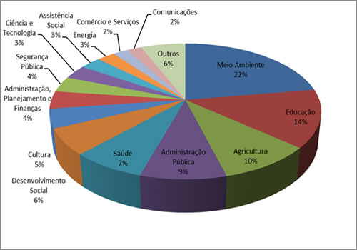

**Figure 44:** International cooperation projects under implementation in 2011, by sector.

**Source:** MRE information at <http://www.abc.gov.br/Projetos/CooperacaoRecebida/ProjetoseAtividades>

The priority focus of bilateral agreements with Germany, Spain, Japan and France is on environmental themes: (i) Brazil-Germany – conservation of tropical forests, renewable energy and energy efficiency; (ii) Brazil-Spain – environment, professional development, tourism, agriculture and aquaculture, and public administration; (iii) Brazil-France – agriculture and environment; (iv) Brazil-Japan – environment, transport and energy.[9]

Current international cooperation initiatives and projects coordinated by the Ministry of the Environment involve the following themes: Antarctic; Antarctic marine living resources; whales; biodiversity; biosafety; ozone layer; desertification; Law of the Sea; threatened species; migratory species; forests – tropical timber; climate change; chemicals – organic pollutants; chemicals – hazardous substances; waste – transportation of hazardous waste; waste – tyres; sea turtles; and wetlands.[10]

Four bi-lateral cooperation activities are implemented through MMA. Brazil-German cooperation on environmental themes has been continuous since 1990, involving mainly activities, initiatives, projects and studies to support the conservation of tropical forests, but also expanding to other environmental or biodiversity themes. Brazil-Norway cooperation on environmental themes have intensified since 2006, particularly regarding the constitution of the Fund for the Preservation and Conservation of the Amazon (*Fundo Amazônia*), and more recently with the support to the development of state plans for preventing and combating deforestation in the Legal Amazon as well as to the implementation of Extractive Reserves in the Amazon. Brazil-European Union cooperation was formally established in 1992 and current technical cooperation themes are forest management (sustainable production and social organization strengthening in the Amazon), and ecological corridors. Brazil-United States cooperation currently occur under the Common Agenda on the Environment, with initiatives related to protected areas management, water resources management, and forest management.[11]

*Mobilization of resources*.[12] From 15 to 17 April 2014, Brazil hosted the Regional Workshop on Resource Mobilization for Latin America and the Caribbean, held in Brasília. The workshop was jointly organized by the CBD Secretariat, UNDP-BIOFIN and UNEP-WCMC, with support from the Brazilian government and financial support from the government of Japan. The workshop addresses the concern on the lack of sufficient resources to achieve CBD targets expressed in paragraph 27 under Decision XI/4 of COP-11 of the CBD. The workshop objective was to assist the Parties in the identification of amounts invested in biodiversity, as well as in the preparation of reports on the national efforts for the mobilization of resources and the preparation of national plans for financing biodiversity conservation. The workshop was attended by 50 resource mobilization experts from Antigua and Barbuda, Bahamas, Bolivia, Brazil, Chile, Colombia, Costa Rica, Cuba, Dominica, Dominican Republic, Ecuador, Grenada, Guatemala, Haiti, Honduras, Mexico, Nicaragua, Paraguay, Peru, Saint Kitts and Nevis, Saint Lucia, Saint Vincent and the Grenadines, and Uruguay. Several United Nations organizations as well as relevant international and national organizations were also represented.

Also in April 2014, Brazil hosted the Third Meeting of the High-Level Panel on Global Assessment of Resources for Implementing the Strategic Plan for Biodiversity 2011-2020. The High-Level Panel is comprised of 15 members, and ensures the fair and equitable geographical representation. The aim of the Panel is to develop an assessment of the benefits of meeting the Aichi Biodiversity Targets, examining both direct biodiversity benefits to society that result from the investments and the policy developments required to achieve biodiversity conservation targets. The Panel will also identify opportunities for improving the use of resources in the biodiversity sector and across economies in order to meet the Aichi Biodiversity Targets in a cost-effective manner.

1. Machado, F.S. et al, 2012. Metas brasileiras de biodiversidade para 2020: exemplo de construção participativa no marco da Convenção de Diversidade Biológica – CDB/ONU. In: Bahia Análise & Dados, vol. 22, No. 3.
2. Machado, F.S. et al, 2012. Metas brasileiras de biodiversidade para 2020: exemplo de construção participativa no marco da Convenção de Diversidade Biológica – CDB/ONU. In: Bahia Análise & Dados, vol. 22, No. 3.
3. Participating institutions: MMA, ICMBio, MCTI, Fiocruz, IUCN, WWF-Brasil, GIZ, APRENDER, FUNDHAM, CI, IPE, Fundação Biodiversitas, ISA, Fórum do Mar, FNB, CNI, and CEBDS.
4. <http://portaldabiodiversidade.sp.gov.br/files/2014/02/Aichi_impressao_06_02_15_pdf_final.pdf>
5. <http://portaldabiodiversidade.sp.gov.br/a-biodiversidade-no-estado-de-sao-paulo>/
6. Information provided by DCBio/SBF/MMA in July 2014.
7. The BRA/11/001 Project is entitled Support to the Implementation of the Commitments under the International Conventions that Address Biodiversity (*Apoio para Implementação dos Compromissos das Convenções Internationais que Tratam da Biodiversidade*).
8. <http://www.abc.gov.br/Projetos/CooperacaoRecebida/ProjetoseAtividades>
9. <http://www.abc.gov.br/Projetos/CooperacaoRecebida/ProjetoseAtividades>
10. <http://www.mma.gov.br/assuntos-internacionais/temas-multilaterais>
11. <http://www.mma.gov.br/assuntos-internacionais/temas-multilaterais>
12. Information provided by MMA/DCBio/SBF in July 2014.